How do biological organisms use energy?

The Importance of ATP
All organisms use a two-step process to provide the energy needed for most of their biological activities.

I. First, chemical energy from organic molecules like glucose is transferred to ATP molecules. This process is called cellular respiration.

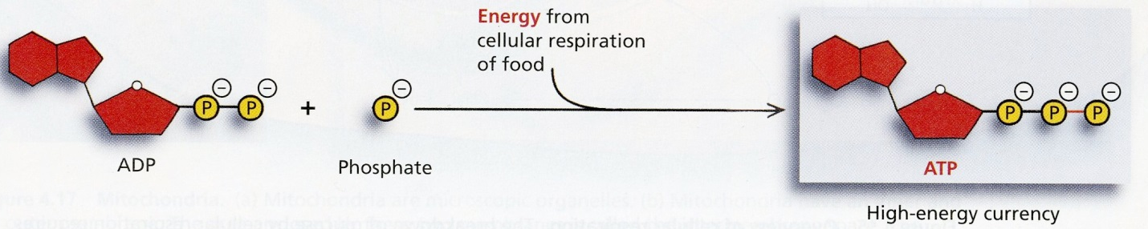
This figure illustrates how energy from cellular respiration of food molecules is used to make ATP by adding a phosphate to ADP. (ADP = adenosine diphosphate (with 2 phosphates);
ATP = adenosine triphosphate (with 3 phosphates))
(Figures from Belk and Borden, Biology: Science for Life, 2007)

II. Then, ATP provides the energy for most biological processes. When ATP breaks down to ADP and a phosphate, this releases energy which is used for many different cellular processes.

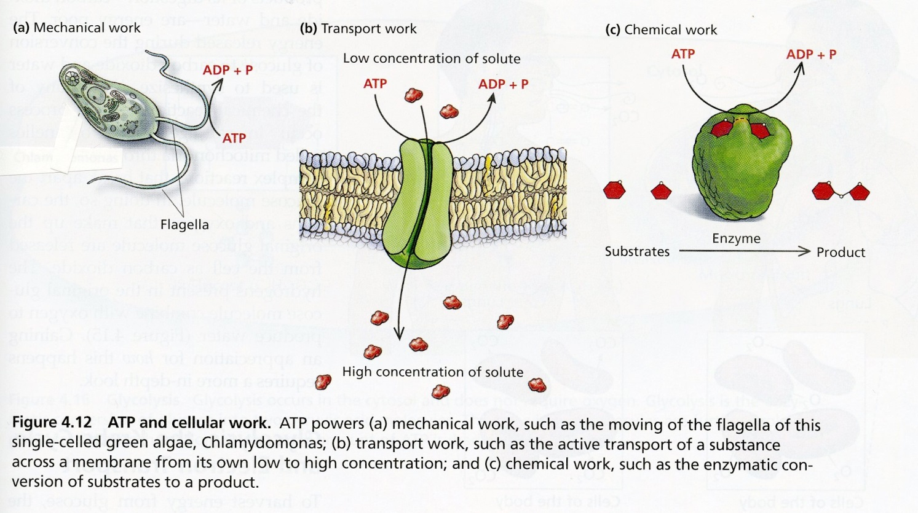

Notice that the role of ATP in biological organisms is somewhat similar to the role of money in our society. Most people use a two-step process to get food, clothing, etc.

I | During cellular respiration, energy is transferred from organic molecules like glucose to ATP. | Most people work to earn money.
II | Then ATP provides the energy for most biological processes. | Then people spend their money to buy the things they need or want.
1. Explain why the reaction, ADP + phosphate ATP, requires energy input. (Hint: Review the top figure on the previous page and remember that like charges repel each other.)

2. Explain why all the cells in your body need to carry out the reaction, ATP ADP + phosphate. How is this reaction useful?

I. Cellular Respiration – Transferring Energy from Organic Molecules to ATP
Cellular respiration is the process that transfers some of the chemical energy in glucose or another organic molecule to chemical energy in ATP molecules. Cellular respiration is a complex process with many steps, but the basic process is as follows:
Cellular respiration breaks down glucose and oxygen and produces carbon dioxide and water; this releases energy which is used to synthesize ATP from ADP and phosphate.

3a. The following pair of chemical equations shows the basic processes of cellular respiration. Write the names of each of the molecules in these chemical equations.

 |  | + | 6 |  | ––––> | 6 | 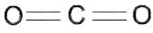 | + | 6 | 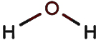
 |  |  |  |  | energy
~29 |  | + | ~29 |  | ––––> | ~29

3b. How do our bodies get glucose for cellular respiration?

3c. Why do we need to breathe all day and all night?

4. If you search for "cellular respiration equation" on the web, some of the most popular sites give the following equation for cellular respiration of glucose.
C₆ H₁₂O₆ + 6 O₂ ----> 6 CO₂ + 6 H₂O + ATP
What is wrong with this equation? (Hint: Think about where the atoms in an ATP molecule come from.)

II. Using ATP to Provide Energy for Biological Processes
The energy released by the breakdown of ATP to ADP and phosphate is used for many biological processes. For example, muscle contraction requires ATP as an energy source.

5. Complete the following diagram to give an overview of how ATP provides the energy for muscle contraction.
many ______ many ______ + many phosphate

_____________

muscle relaxed muscle contracted

6. Inside a cell, ATP is constantly broken down to ADP plus phosphate, and ATP is constantly being made from ADP plus phosphate (labeled P in this diagram). Complete the diagram to show how the breakdown of ATP is useful and how new ATP molecules are made.

Two important general principles about energy are:
- Energy can be transformed from one type to another (e.g. the stored chemical energy in ATP can be transformed to the kinetic energy of muscle motion). However, energy can not be created or destroyed by biological processes.
- All types of energy conversion are inefficient and result in the production of heat. For example, when ATP provides the energy for muscle contraction, only about 20-25% of the chemical energy released from the ATP molecules is captured in the kinetic energy of muscle contraction. The rest of the energy from the ATP is converted to heat.

7a. Some textbooks claim that "Cellular respiration makes the energy needed for biological processes." Explain what is wrong with this sentence and give a more accurate sentence.

7b. Explain why your body gets warmer when you are physically active.

By Dr. Ingrid Waldron, University of Pennsylvania, 2014. Teachers are encouraged to copy this Student Handout for classroom use. A Word file (which can be used to prepare a modified version if desired), Teacher Notes with teaching suggestions, background information and alignment with Next Generation Science Standards are available at http://serendip.brynmawr.edu/exchange/bioactivities/energy.

